**ANONYMOUS AUTHENTICATION SCHEME FOR SMART**

**CLOUD BASED HEALTHCARE APPLICATIONS**

**ABSTRACT**

Various sharp restorative administrations applications are grasping cloud to offer organizations to patients. In any case, the unstable data can be uncovered to the approval server/pro center. Thusly, security and assurance are fundamental to its thriving and sending wherever scale. Patients would incline toward not to reveal their identities to the cloud server. One way to deal with shield their identities from cloud server is puzzling approval. The approval process usually incorporates disclosing customers' private information for instance, username and mystery key to the approval server. If the patient can be associated or taken after by the affirmation server or then again poisonous adversaries by their sales, their insurance can be broken. Most of the present security sparing therapeutic administrations applications give anonymity from the foes. Regardless, not a lot of them give anonymity from the approval server. In this paper, we have proposed a structure which gives complete security and anonymity to the customers of restorative administrations applications from foes and the check server. In our proposed confirmation plot, we have utilized turning accumulate signature plot in perspective of Elliptic twist cryptography (ECC) to offer lack of clarity to the patients. To incorporate an extra layer of confirmation, we have used The Onion Router (TOR) to give security at the framework layer. The execution of our arrangement is evaluated by speculative examination which shows that it restricts distinctive strikes and gives a couple of appealing security features.

|  |  |
| --- | --- |
| **EXISTING SYSTEM** | **PROPOSED SYSTEM** |
| **EXISTING CONCEPT:-**   * In existing system now a days in hospitals lot of patients are coming to hospital the hospital management don’t know weather who is coming to admit in hospital how is going to register they are not identifying. * And what is the problem also they are not understanding clearly. * If any emergency case is there they are not getting operation at correct time to overcome all those problems we are going to implement some methods in proposed system. | **PROPOSED CONCEPT:-**   * In proposed system to overcome all these type of problems while joining to hospital they have to register first . * After registration admin will provide one id to that patient. by using that id they have to login. * After login of that page where is one menu under that for that patient what the user need they have to send a request to admin for what the requirement they need . * If admin will receive that request. Immediately .they will respond and they will provide concernperson . |
| **EXISTING ALGORITHM:-**   * Single Encryption algorithms | **PROPOSED ALGORITHM:-**   * revocation algorithm |
| ALGORITHM DEFINITION**:-**   * Encryption is the process of converting a plaintext message into cipher text which can be decoded back into the original message. An encryption algorithm along with a key is used in the encryption and decryption of data. There are several types of data encryptions which form the basis of network security. Encryption schemes are based on block or stream ciphers. The type and length of the keys utilized depend upon the encryption algorithm and the amount of security needed. In conventional symmetric encryption a single key is used. With this key, the sender can encrypt a message and a recipient can decrypt the message but the security of the key becomes problematic. In asymmetric encryption, the encryption key and the decryption key are different. One is a public key by which the sender can encrypt the message and the other is a private key by which a recipient can decrypt the message. | ALGORITHM DEFINITION**:-**   * By using these algorithm if any user is going to register they get one id to login then only they can login if user want any usage they have to ask the permission from admin like a request form . |

**SYSTEM ARCHITECTURE:**

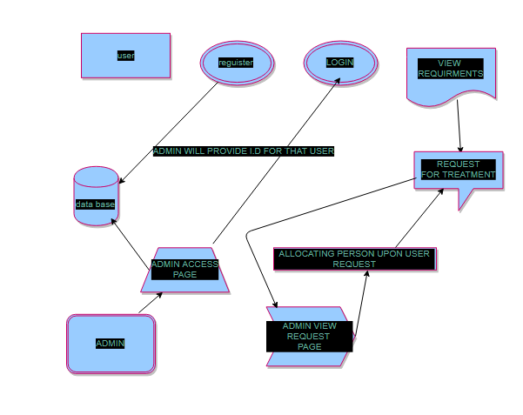

**MINIMUM SYSTEM REQUIREMENTS:**

**HARDWAREREQUIREMENTS**

PROCESSOR : DUAL CORE

RAM : 4 GB DD RAM

MONITOR : 15” LCD, LED MONITOR

HARD DISK : 250 GB

**SOFTWAREREQUIREMENTS**

FRONT END : JAVA (J2EE, SERVLETS, JSP)

BACK END : MY SQL

OPERATING SYSTEM : WINDOWS, MAC, LINUX

IDE : ECLIPSE

**Algorithm Explanation**

**A. Initialization**

The system initialization is done once, when Group Manager sets up the system.

1) Group Manager generates Id. To the users

**B. Key Generation**

CSP will generate the long term private signing key along with Id.

**C. Registration**

When user joins the group he registers with Registration Server to get a key for the current group.

1) User connects to RS over a secure channel.

2) User demonstrates his identity to RS with, for instance, a username and password

**D. Authentication**

When user wishes to request services represented by CSP, he begins the authentication process:

1) User connects to CSP over an anonymous network.

2) User sends the Id to authenticate with.

3) CSP verifies the Id matches a stored Id from Group Manager

4) CSP generates a random secret key and sends it to user.

**E. Revocation**

When group manager discovers that a user, let’s say patient has been abusing the service, he cancel patient’s key means patient can’t access the services provided by the CSP.